**K. J. Somaiya College of Engineering, Mumbai-77**

Semester: ODD 22-23

Sample Question for fourier series

**Instructions**

**Make a word file in the following manner and upload the file on LMS**

|  |  |  |
| --- | --- | --- |
| Steps | Details | Marks (25) |
| 1 (on the top of page) | Name  Batch & Roll no  Tutorial Name and date | - |
| 2 | File name :P2-RollNo-Batch no_Name  Eg.P2-16010421001-A1- TANUSHREE ACHARYA | 1 |
| 3 | Question1  Code on Scinotes(n=50)  Output(n=50)  Code on Scinotes(n=10)  Output(n=10) | 1  2  3  2  3 |
| 4 | Question2  Code on Scinotes(n=50)  Output(n=50)  Code on Scinotes(n=10)  Output(n=10) | 1  2  3  2  3 |
| 5 | Submission during tutorial time | 2 |

Name: Tirth Patel

Batch & Roll no: A3 16010421075

Tutorial Name and date: Scilab Tutorial 2 06/09/2022

Q1 Draw graph of the function and its fourier series (with n=50,n=10)

$$f\left(x\right)=xcos(x) , -π≤x≤π$$

Code :

clc

L=%pi

x=-L:0.01:L;

f=x.*cos(x);

a0=(1/(2*L)*inttrap(x,f));

for n=1:50

f1=f.*cos(%pi*n*x*(1/L));

a(n)=(1/L)* inttrap(x,f1);

end;

for n=1:50

f2=f.*sin(%pi*n*x*(1/L));

b(n)=(1/L)* inttrap(x,f2);

end;

subplot(2,1,1), plot(x,f); *// subplot(2,1,1)-in display 2 rows & 1column,’1’represnts first graph of function;*

u=0; y=0;h=0;

for n=1:50

u= a(n)*cos(%pi*n*x*(1/L))+ b(n)* sin(%pi*n*x*(1/L))+y;

y=u;

end;

fs=y+ a0;

subplot(2,1,2), plot(x,fs); *// subplot(2,1,2)-in display 2 rows & 1column,’2’represnts first graph of fourier series*

title('Tirth Patel 16010421075 GRAPH1ifn=50','fontsize',5)

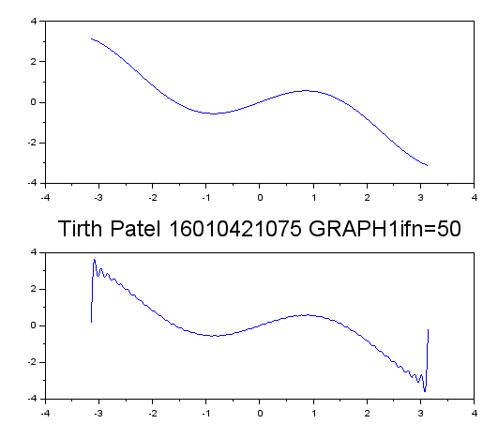

clc

L=%pi

x=-L:0.01:L;

f=x.*cos(x);

a0=(1/(2*L)*inttrap(x,f));

for n=1:10

f1=f.*cos(%pi*n*x*(1/L));

a(n)=(1/L)* inttrap(x,f1);

end;

for n=1:10

f2=f.*sin(%pi*n*x*(1/L));

b(n)=(1/L)* inttrap(x,f2);

end;

subplot(2,1,1), plot(x,f); *// subplot(2,1,1)-in display 2 rows & 1column,’1’represnts first graph of function;*

u=0; y=0;h=0;

for n=1:10

u= a(n)*cos(%pi*n*x*(1/L))+ b(n)* sin(%pi*n*x*(1/L))+y;

y=u;

end;

fs=y+ a0;

subplot(2,1,2), plot(x,fs); *// subplot(2,1,2)-in display 2 rows & 1column,’2’represnts first graph of fourier series*

title('Tirth Patel 16010421075 GRAPH2ifn=10','fontsize',5)

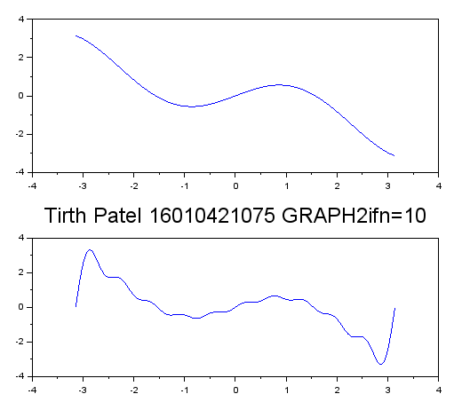

Q2 Draw graph of the function and its fourier series (with n=50,n=10)

$$f\left(x\right)=2+x^2, 0≤x≤2π$$

Code:

clc

L=%pi

x=0:0.01:2*L;

f=2+(x.*x);

a0=(1/(2*L)*inttrap(x,f));

for n=1:50

f1=f.*cos(%pi*n*x*(1/L));

a(n)=(1/L)* inttrap(x,f1);

end;

for n=1:50

f2=f.*sin(%pi*n*x*(1/L));

b(n)=(1/L)* inttrap(x,f2);

end;

subplot(2,1,1), plot(x,f); *// subplot(2,1,1)-in display 2 rows & 1column,’1’represnts first graph of function;*

u=0; y=0;h=0;

for n=1:50

u= a(n)*cos(%pi*n*x*(1/L))+ b(n)* sin(%pi*n*x*(1/L))+y;

y=u;

end;

fs=y+ a0;

subplot(2,1,2), plot(x,fs); *// subplot(2,1,2)-in display 2 rows & 1column,’2’represnts first graph of fourier series*

title('Tirth Patel 16010421075 GRAPH3ifn=50','fontsize',5)

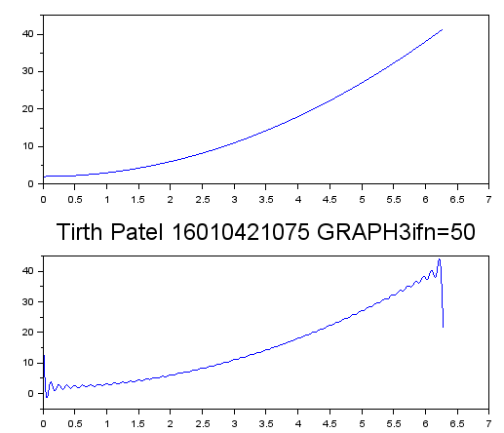

clc

L=%pi

x=0:0.01:2*L;

f=2+(x.*x);

a0=(1/(2*L)*inttrap(x,f));

for n=1:10

f1=f.*cos(%pi*n*x*(1/L));

a(n)=(1/L)* inttrap(x,f1);

end;

for n=1:10

f2=f.*sin(%pi*n*x*(1/L));

b(n)=(1/L)* inttrap(x,f2);

end;

subplot(2,1,1), plot(x,f); *// subplot(2,1,1)-in display 2 rows & 1column,’1’represnts first graph of function;*

u=0; y=0;h=0;

for n=1:10

u= a(n)*cos(%pi*n*x*(1/L))+ b(n)* sin(%pi*n*x*(1/L))+y;

y=u;

end;

fs=y+ a0;

subplot(2,1,2), plot(x,fs); *// subplot(2,1,2)-in display 2 rows & 1column,’2’represnts first graph of fourier series*

title('Tirth Patel 16010421075 GRAPH4ifn=10','fontsize',5)

